Lecture 18, October 21, 2010 (Key Points)

New Physical Foundations of River-Basin Hydrology with Applications to Floods

18.1. Specification of spatially distributed hillslope-link scale conservation equations for multi-scale rainfall-runoff dynamics in River Basins

- To understand how hydrographs vary in space and time throughout a river network in terms of physical processes, we will use the equation of mass conservation, or the continuity equation as a "local-difference equation". It is one of the three fundamental physical equations of fluid mechanics. The second and third are the equations of momentum and energy conservation. Continuity equation can be regarded as the most basic equation of hydrology from first principles (Dooge 1997).

- Consider a link-hillslope system that corresponds to a natural terrain in Fig. 18.1

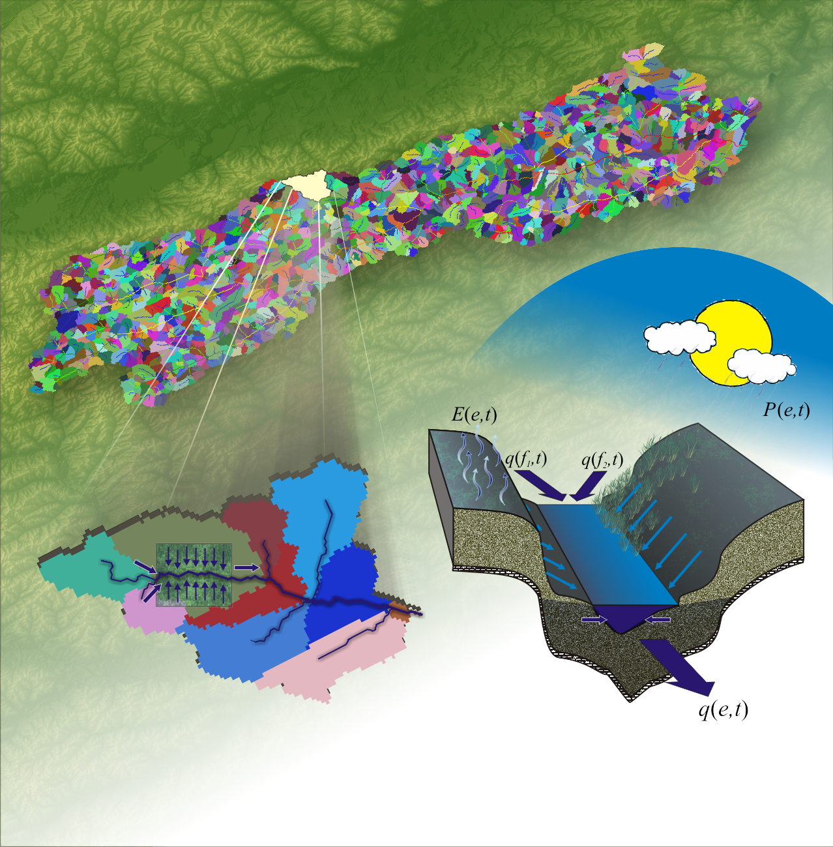
Figure 18.1 Hillslope-Link partitioning corresponding to a natural terrain

- Assume that at an appropriate scale of resolution of terrain, e.g. a 30 m DEM, a drainage network τ can be represented as a finite binary tree. In a binary tree, by definition, the upstream end of every internal link is joined by two links. A binary tree consists of links, junctions, sources, and the outlet like all trees. A junction is defined as a point where three channels meet. A source denotes the starting point of an unbranched channel, and a link is a channel segment between two junctions (internal link), a source and a junction (external link), or the outlet and a junction (internal link). The outlet is a privileged junction that "directs" or drains water from any location within the entire channel network, and no other junction has this property.

- A natural way to assign a size to a network τ is by equating it to the total number of sources, or external links, called magnitude. For example, for a binary tree with magnitude m, total number of links is 2m-1 (Lecture 11). It is proportional to the drainage area of a basin, or , where ‘a’ is the mean hillslope area.

- Assume that flow in a network is observed in multiples of a time scale 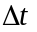 at times 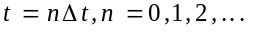. As an example, one may take as the time it takes for water to flow through a link with some 'mean velocity' , i.e., 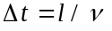, where l is the assumed to be the constant link length for all links. From here on we will suppress and simply write 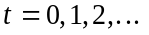. Let 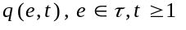 be a space-time field representing river discharge, or the volume of flow per unit time, across a link in the time interval 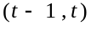=. The out flow discharge of a link from its bottom vertex in the time interval is .

6. Let 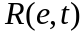 denote a hillslope runoff hydrograph (length per unit time) adjacent to the link in time interval . Let a(e) denote the combined areas of two hillslopes. Assume for simplicity that is the same for both hillslopes (Strictly speaking it is different due to spatial variability among hillslopes). We can write a water balance equation for as (Gupta and Waymire, 1998),

(18.1)

where, is the total volume of stored water on the hillslopes, both surface and subsurface. is precipitation. is evapotranspiration that depends on the , and so does hillslope hydrograph, . Duffy (1996) is a good reference to get more details of hillslope hydrograph from runoff-generation processes.

7. may also include the runoff depletion per unit time due to channel infiltration, as in the Walnut Gulch basin, or evaporation from channel surface in link . But we will not analyze the problem in such detailed physical generality.

- Let denote the total volume of runoff stored in link in time interval 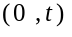, and the change in the total volume of runoff stored in time interval , as 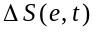. Then the equation of continuity for a link-hillslope system can be written as (Gupta and Waymire, 1998),

(18.2)

The terms, and 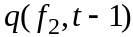 on the right-hand side represent discharges from the two upstream links into link e (Fig. 18.1). The formulation of the continuity equation does not require that the channel network is binary. This means that more than three links can be present at a junction, but this situation does not arise in river networks
that are binary. However, it assumes that no loops are present in the network.

- In real networks, link lengths are random, and consequently, one cannot define a characteristic time scale, , as in the case of constant link lengths. Eq. (18.2) is useful for idealized networks that have been analyzed in the literature.

- For real networks, we take time to be continuous by letting in Eq. (18.2), and rewrite it as,

(18.3)

- A functional relationship between link storage and link discharge 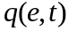 is needed to express Eq. (18.3) in terms of one dependent variable. It can be obtained from the definition of storage and discharge, and a specification of the link velocity, from a momentum balance equation for a channel link (Kean and Smith 2005).

- Recall Chezy equation (lecture 16), for a wide channel. A storage-discharge relationship for a wide channel is given by (Menabde and Sivapalan 2001),

(18.4)
Substituting for in the expression for storage gives a storage-discharge relation,

(18.5)

Here, is the link length, is the link width, and is the link slope. Substituting Eq. (18.5) into Eq. (18.3) gives,

(18.6)

where,

(18.7)

18.2. Four sets of physical hydrologic conditions and processes for a solution

1. Characterization of network topology and/or geometry
Coupled differential Eqs. (18.6) and (18.1) are solved in a channel network, which enables you to predict stream flow hydrographs at all junctions in a basin. The solution depends on channel network topology and geometry. Self-similarity in channel network topology and geometry plays a foundational role in understanding the structure of space-time hydrographs on a network. We will give three examples.

2. Estimation and modeling space-time rainfall intensity field
We will introduce modern developments regarding precipitation in later lectures.

3. Physical descriptions of runoff generation from hillslopes along a river network
Point infiltration concepts are introduced in existing hydrology courses. Integrating the point-scale physical equations to obtain Hillslope-scale hydrograph in Eq. (18.1) is described in Duffy (1996). But, it is a current research topic. However, a very large number of hillslopes exist in a river basin (GCEW has ~800), which produces ‘dynamic parametric complexity’. How to tackle this problem is a key open question in modern hydrology that will be covered later on.

4. Specification of hydraulic-geometric (HG) variables for runoff dynamics
The HG variables are width, depth, velocity, channel friction, and slope for each link, as shown in Eq. (18.7). We will discuss this issue in more detail later in this course.

Once all the four sets of physical processes are specified, coupled Eqs. (18.1) and (18.6) can be solved iteratively to obtain flow hydrographs at the bottom of every link in a basin, which includes all subwatersheds. The solutions depend on the spatial branching and geometric structure of a channel network through the terms 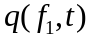 and 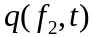. We will give four examples to illustrate this key idea. The first three examples are devoted to explaining how the width function GIUH arises as a solution of Eq. (18.2), the discrete-time version. The fourth example covers scaling in peak flows for RF-RO events.

References

Duffy, C. A two state integral balance model for soil moisture and groundwater dynamics in complex terrain, Water Resour. Res., 32(8): 2421-2434, 1996.

Dooge, J. C. I. Scale Problems in Hydrology. In: Reflections on Hydrology: Science and Practice, Ed. (N. Buras), Amer. Geo. Union, Washington D C, 1997.

Gupta V. K. and E. Waymire. Spatial variability and scale invariance in hydrologic regionalization. In: Scale dependence and scale invariance in hydrology, G. Sposito (ed.), 88–135, Cambridge, 1998.

Jarvis, RS, and MJ Woldenberg, River networks, in Benchmark Papers in Geology, vol. 80, edited by R. S. Jarvis and M. J. Woldenberg, 386 pp., Van Nostrand, 1984.

Kean, J, and J. D. Smith. Generation and verification of theoretical rating curves in the Whitewater River basin. J. Geophys. Res. 110: F040-12, 2005.

Menabde M, and Sivapalan M. Linking space-time variability of rainfall and runoff fields: A dynamic approach, Adv. Water Resour., 24, 1001-14 (2001).

